

CMT UAT Training Document
June 16, 2023
Version 1.2

Table of Contents
1.CMT Overview 3
1.1 Overview 3
1.2 Problem statement 3
1.3 Objective 3
1.4 Solution Overview - High Level Integrated Flow 4
2. CMT UI Tour 6
2.1 CMT Login 6
2.1.1 Access Approvals 8
2.1.1.1 Domestic Approvals 8
2.1.1.2 International Approvals 9
2.2 Dashboard 10
2.3 Inbox 11
2.3.1. Unprocessed 11
2.3.2. Processed 12
2.4 Email View 13

1.CMT Overview

1.1 Overview
The Carrier Management Tool (CMT) is used to process carrier emails. Carriers send emails about maintenance on circuits leased by Verizon. CMT processes the emails to generate maintenance in MASTARS. This application is used to read mail coming from external carriers and parse the email, extract the data like location (city, state (for US based maintenances), country), outages (duration and unit of measure), reference number, network elements (Circuit, Device, Fiber, or Ring) , start time and end time of the maintenance, as well as attachments if those are supplied by the carrier.

1.2 Problem statement
- The system is a slow and heavy manual process. Backlog change notifications have grown to be 1000+ pending to be processed at times and notifications are not processed in time, Verizon is paying fines and penalties for not informing Verizon customers about outages and changes.
- The existing platform is antiquated and not maintained to the current performance standards.
- This is a monolithic application that does not meet NorthStar guidelines.
- Carriers keep changing the format of the notification emails without notice causing issues with the existing models.
- The current models implemented to help parse emails are not yielding expected results.
- Lack of maintenance and upkeep of models and application performance.
- High Dependency on Legacy MASTERS application that needs to be sunset.
- Current design has some sort of automation, but if some data isn't processed fully - all results of the parsing are deleted. Therefore, users need to make analysis from scratch.
- New model needs to be introduced every time we have a new carrier.

1.3 Objective
- Process Unification so that both Wireline (OCC, IDNC, PTT) and Wireless can be merged
- Forward looking with API first design and ability for direct Carrier API Integration
- Standardization of the message content. So, it can be adopted into an API or common carrier information exchange guidelines published by TMforum
- Improve system performance & automation to process automated/manual carrier notification and increase GEMC productivity (less than 1 hour)
- Transparency and visibility of automated processing vs manual override of information contained in the emails
- Limit the manual involvement in the process for users and speed up the process of validation of the information.
- Multi language support - (English-(US, UK), German, Spanish and Mandarin Chinese is a must).

1.4 Solution Overview - High Level Integrated Flow
- Modularized automated pre-processing engines to standardize and eliminate noise from the notifications.
- Identification and extraction of standard and derived information contained in message
- Enable a common message exchange format.
- Modularization and Enablement of future API endpoint development for standardized exchange of notifications
- Email processed done by CMT automation tool
- CMT will process the email and extract the content from it
  - Carrier Name (derived from the domain of the sender)
  - Network elements (Circuits, devices)
  - Start Date of the Maintenance (returned in UTC format by the parser if available)
  - End Date of the Maintenance (returned in UTC format by the parser if available)
  - Outage Duration (downtime that maintenance cause for the network elements)
  - Outage Unit of Measure (goes in tandem with outage duration, describing its uom time)
  - Location
    - city (for international location sometimes can be marked as country too )
    - state (for US only)
    - country
  - Attachments
    - support different attachment views like (.pdf, .doc, .docx, .xlsx, .txt, .json, .csv, etc.)
- Note: one of the main features in semi-processed emails (the ones that have no full info extracted), all the results will be saved to DB so the user can use parser extraction and limit manual work.
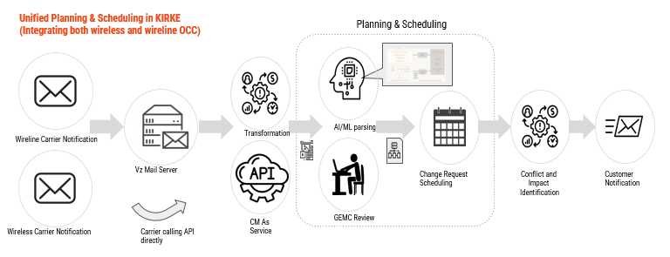

2. CMT UI Tour

2.1 CMT Login
- Go to: https://kirke-uat.ebiz.verizon.com/cmt/
- Enter your SSO Login info (i.e. 5+2 Login) and password
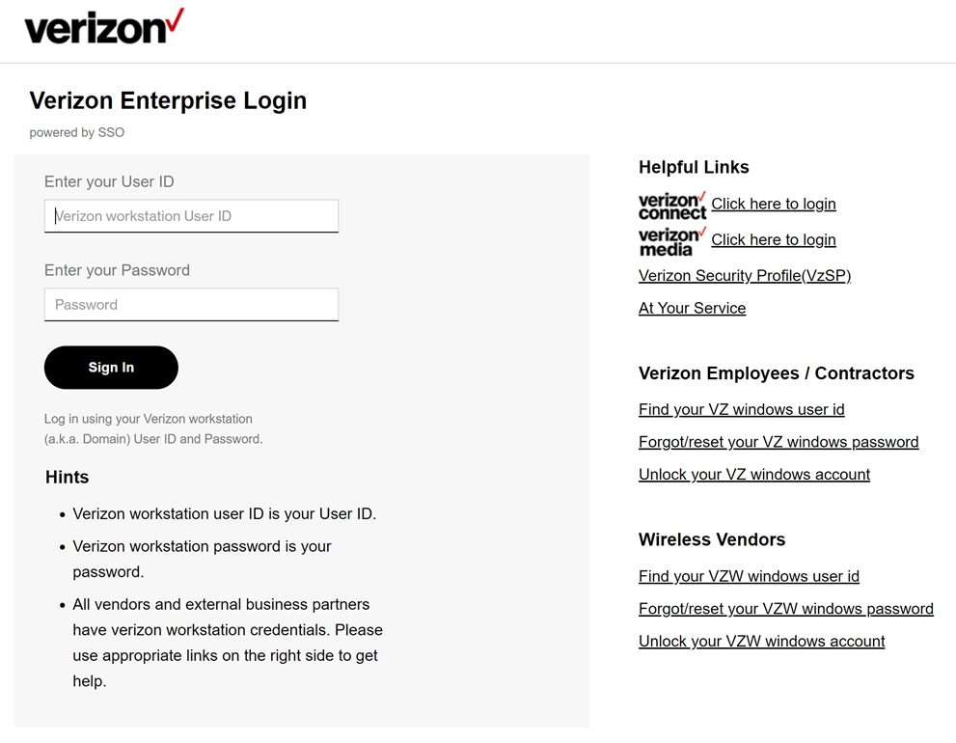
- If user has access then page redirected into CMT Dashboard
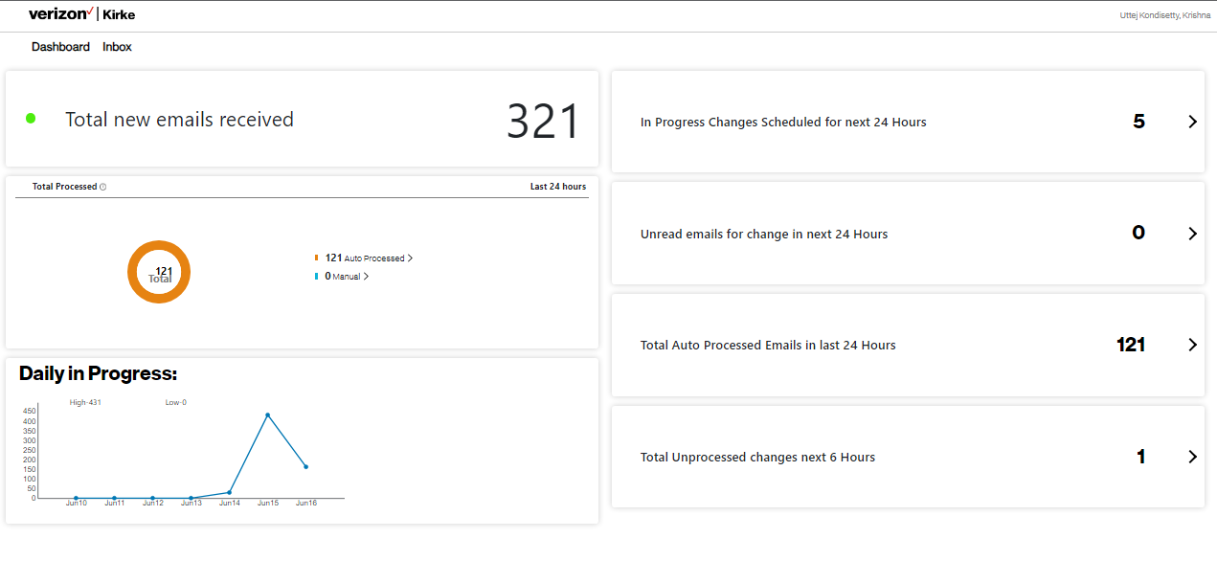
- If user didn’t have access then select User for the role and submit
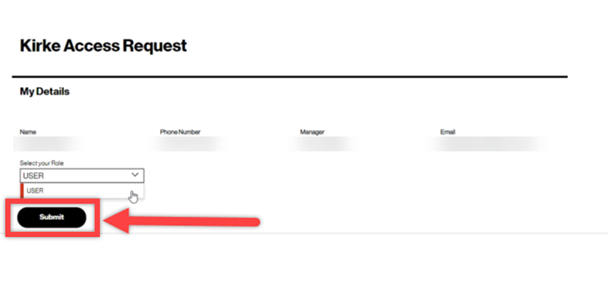
- If successful, you should receive the following screen
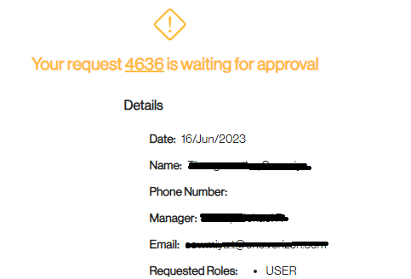
If instead you receive an error message you will need to open an AYS ticket to have the issue investigated by Production Support.

2.1.1 Access Approvals
Your manager will get an email to approve the request. However, if you report into a contractor then the next manager within your reporting chain that is Verizon will have to approve your request.

If the manager/supervisor does not find the email in their mailbox, it may have gotten shuffled into a filter. Perform a whole-mailbox search for a Subject beginning with “Kirke: USER access request for”. If the email is still not found, please open an AYS ticket to have Production Support investigate why the email was not received

2.1.1.1 Domestic Approvals
Domestic VZ Employees - Managers/Supervisors are responsible for approving their own team’s access requests via the email notification supplied by Kirke.
Domestic Contractors - Managers/Supervisors are responsible for approving their own team’s access requests via the email notification supplied by Kirke. Also if you report to a manager that is also a contractor, your request continues up your reporting chain until it finds a Verizon employee.

2.1.1.2 International Approvals
When a manager/supervisor approves an International employee, Kirke will prompt for the Global Clearance number to be provided:
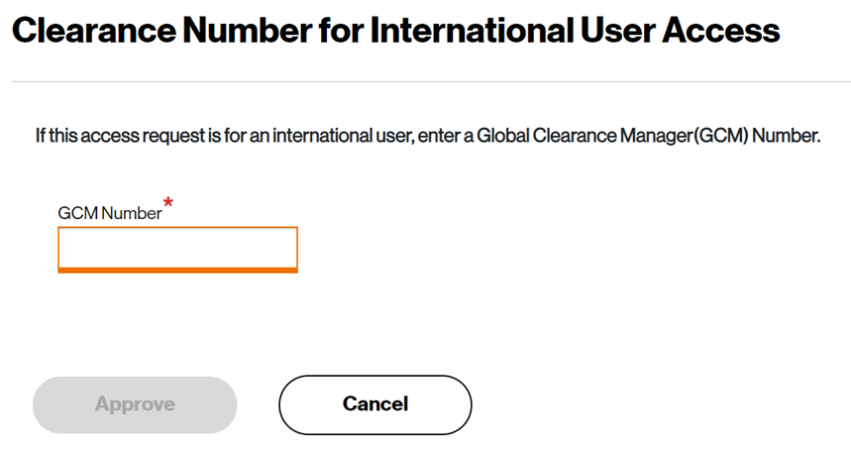

International Vz Employees - Managers / Team Leaders are responsible for providing the GCM approval for your team for access to Kirke Production, please ensure that you always quote the correct Global Clearance ID.

International contractors - Managers / Team Leaders are responsible for providing the GCM approval. However, the clearance ID of the contractor varies and is dependent on if clearance has been sought by the responsible manager for that contractor. Also if you report to a manager that is also a contractor, your request continues up your reporting chain until it finds a Verizon employee.
Approving Kirke International user access with the correct GCM ID is the responsibility of the approving manager.
If you need to know what the Vz Employees/Contractors GCM ID are, please contact Pamela Menezes or Linsie Keen.

2.2 Dashboard
When users click the CMT address (https://kirke-uat.ebiz.verizon.com/cmt/), if they have access then they are directed to the dashboard.
Dashboard has the following options
- Total new emails received
  - Users can see email counts which are all total new emails received from pipeline script.
  - Click “Total new emails received” text and it will redirect to the inbox where total new mails received.

- Total processed in last 24 hours
  - Graphical view shows the total auto processed and manually processed email count for last 24 hours
  - Auto processed : Emails in which CMT extracted all data
  - Manual: Emails in which CMT extracted few data

- Daily in progress of unprocessed emails for the past seven days
  - User can see email count which daily progress of unprocessed emails for the past seven days

- In progress changes scheduled for next 24 hour
  - User can see email count which are scheduled in next 24 hour
  - Click on "In progress changes scheduled for next 24 hour" and it will redirect to inbox containing In unprocessed emails scheduled in next 24 hour

- Unread emails for change in next 24 hours
  - User can see email count which are unread unprocessed emails scheduled in next 24 hours
  - Click “Unread emails for change in next 24 hours” text and it will redirect to inbox containing unread emails scheduled in next 24 hours

- Total auto processed emails in last 24 hours
  - User can see email count which are total auto processed emails in last 24 hours
  - Click “Total auto processed emails in last 24 hours” text and it will redirect to inbox containing total auto processed emails in last 24 hours

- Total unprocessed changes in next 6 hour
  - User can see email count which are total unprocessed emails scheduled in next 6 hour
  - Click “Total unprocessed changes in next 6 hour” text and it will redirect to inbox containing Total unprocessed emails scheduled in next 6 hour
Dashboard Page View

2.3 Inbox
- When users click the inbox option at the top, the inbox list appears.
- Users will see processed and unprocessed emails in the inbox page
- Users have the filter options for all the columns.

2.3.1. Unprocessed
The following columns are displayed in the unprocessed table
- Notification ID
  - The sequential number of the message in the database
- Carrier
  - Get if from the stored dictionary of the carrier that we work with.
- Subject
  - Email subject which is extracted from automated process. If users mouse over the subject they will see the full subject content.
- Received mail
  - Date when email is received
- Attachments
  - Display the attachment icon if the email has an attachment.
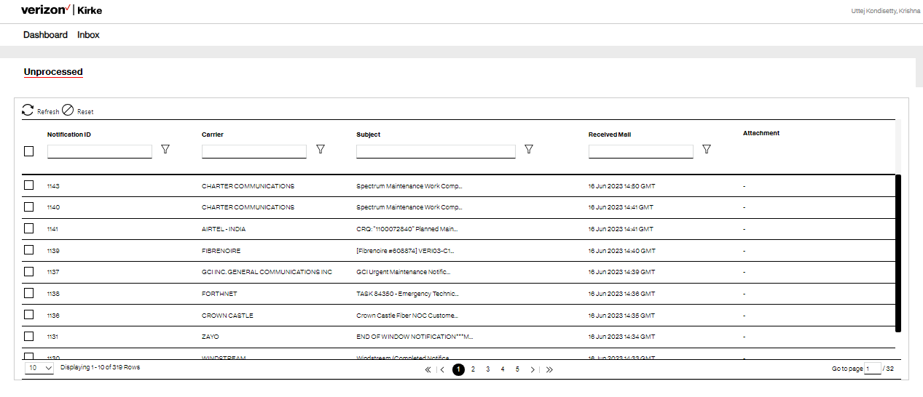
Unprocessed Inbox Folder

2.3.2. Processed
The following columns are displayed in the processed table
- Request ID
  - Processed email will get assigned the Kirke Request ID, that can be used to navigate directly to the Kirke page and view the request fully.
- Notification ID
  - The sequential number of the message in the database
- Carrier
  - Get if from the stored dictionary of the carrier that we work with.
- Subject
  - Email subject which is extracted from automated process. If users mouse over the subject they will see the full subject content.
- Received mail
  - Date when email is received
- Days Until
  - Days left until the maintenance will start
- Attachments
  - Display the attachment icon if the email has a single or multiple attachments.
- Locked
  - Users will mark the email as lock then that email can’t be edited by another user.
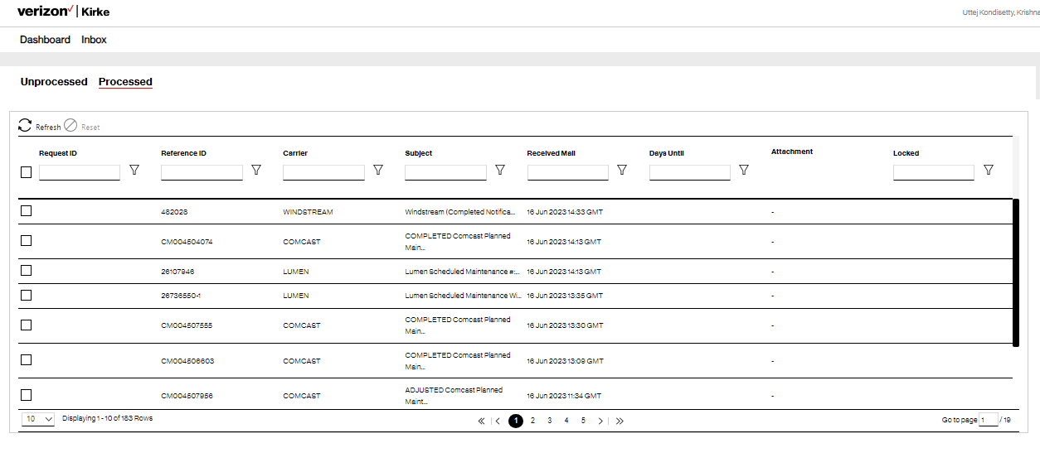
Processed Inbox Folder

2.4 Email View
- Users are redirected to the email view page when they click any email in their inbox.
- This page contains left and right side panel
In the view page, users will see the parsing data on the left side panel.
- Carrier name:
  - The Carrier Name is highly correlated with the sender’s domain.
- Sender email
  - Email id from the sender.
- Subject
  - This displays the subject for the email
- Location
  - This display the city, state and country
- Work description
- Actual start (start time of the maintenance in UTC )
- Actual end (end time of the maintenance in UTC )
- Outage duration (duration of the outage )
- Outage UOM (outage duration parameters (seconds, minutes, hours))
- Network elements(Unverified)
  - Circuits
  - Devices

In the view page, users will see the email body on the Right side.
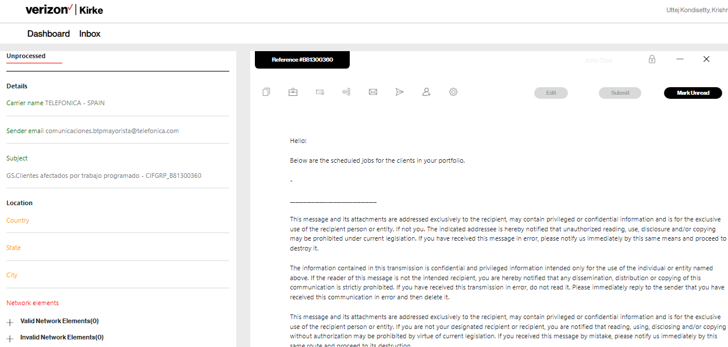
Note : The above image’s right top icons, including Edit and Submit, are not functional. They will be implemented in the future phases.
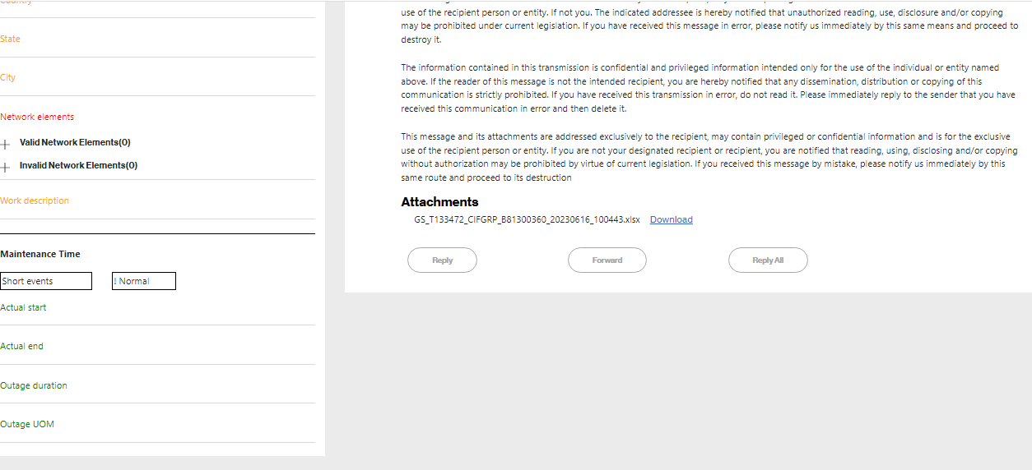
Below screenshot, left and right side users can see the parsing and non parsing network elements (Circuit ID) .
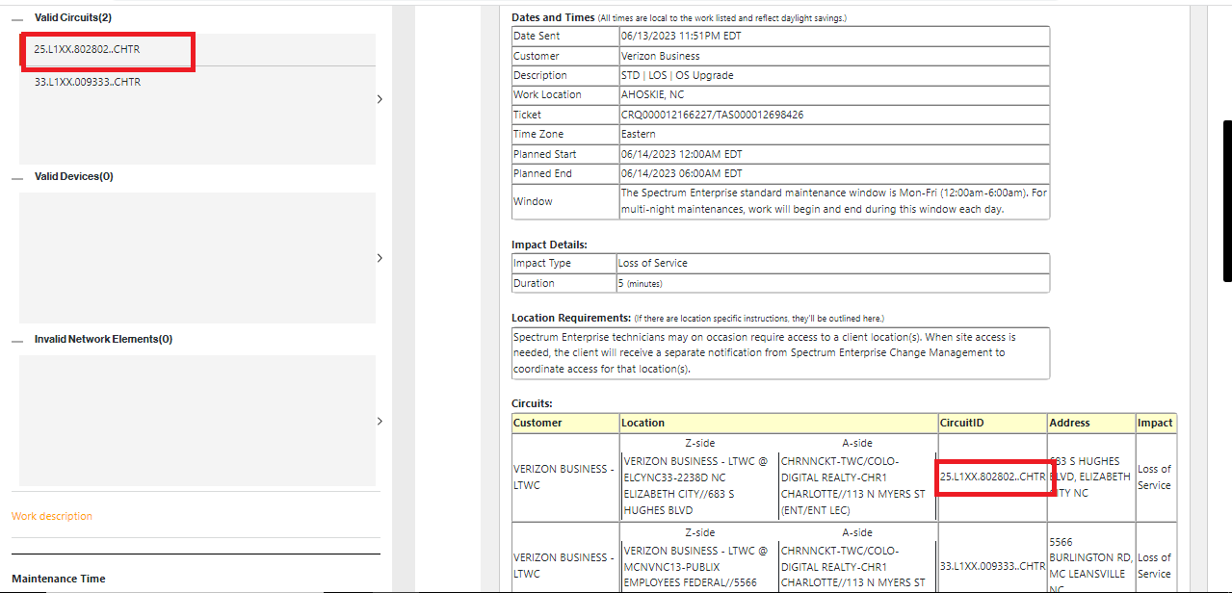
Attachments:
- If email has attachments then that is listed in the email view page
- Users has two options
  - View attachments
    - File type : Text, HTML, JSON, PDF, DOC, CSV
  - Download attachments
    - File type :DOCX, XLSX, etc.

View attachments :
- When a user clicks the view button, they will view attachment files.
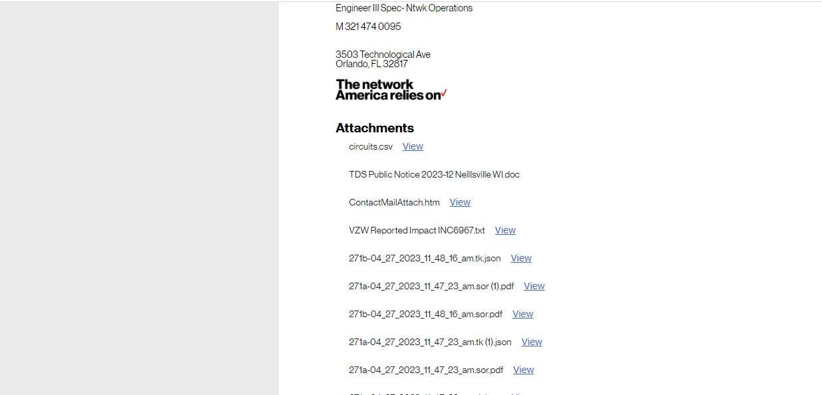
- If user clicks circuits.csv then they will see data in popup
- If the user clicks the close button, then the popup will be closed.
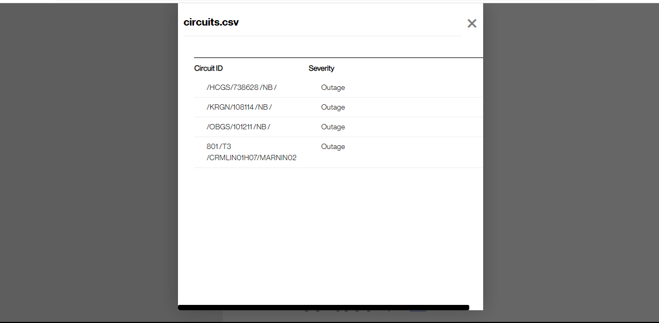

Download attachments:
If the email has Docx or xlsx in the attachments then users can download it.
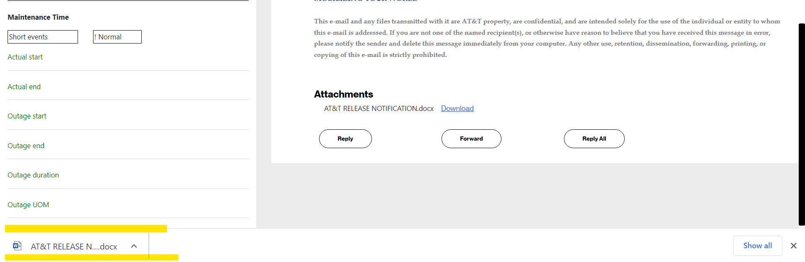
Downloaded file
